|  |  |  |  |  |  |  |  |  |  |
| --- | --- | --- | --- | --- | --- | --- | --- | --- | --- |
| **SCHOOL OF COMPUTER SCIENCE AND ARTIFICIAL INTELLIGENCE** | | | | | **DEPARTMENT OF COMPUTER SCIENCE ENGINEERING** | | | | |
| **ProgramName:**B. Tech | | | | **Assignment Type: Lab** | | | **AcademicYear:**2025-2026 | | |
| **CourseCoordinatorName** | | | | Venkataramana Veeramsetty | | | | | |
| **Instructor(s)Name** | | | | |  | | --- | | Dr. V. Venkataramana (Co-ordinator) | | Dr. T. Sampath Kumar | | Dr. Pramoda Patro | | Dr. Brij Kishor Tiwari | | Dr.J.Ravichander | | Dr. Mohammand Ali Shaik | | Dr. Anirodh Kumar | | Mr. S.Naresh Kumar | | Dr. RAJESH VELPULA | | Mr. Kundhan Kumar | | Ms. Ch.Rajitha | | Mr. M Prakash | | Mr. B.Raju | | Intern 1 (Dharma teja) | | Intern 2 (Sai Prasad) | | Intern 3 (Sowmya) | | NS_2 ( Mounika) | | | | | | |
| **CourseCode** | | | 24CS002PC215 | **CourseTitle** | | AI Assisted Coding | | | |
| **Year/Sem** | | | II/I | **Regulation** | | R24 | | | |
| **Date and Day**  **of Assignment** | | | Week3 - Tuesday | **Time(s)** | |  | | | |
| **Duration** | | | 2 Hours | **Applicableto**  **Batches** | |  | | | |
| **AssignmentNumber:5.2**(Present assignment number)/**24**(Total number of assignments) | | | | | | | | | |
|  | | | | | | | | | |
|  | **Q.No.** | **Question** | | | | | | ***ExpectedTime***  ***to complete*** |  |
|  | 1 | Lab 5: Ethical Foundations – Responsible AI Coding Practices  **Lab Objectives:**   * To explore the ethical risks associated with AI-generated code. * To recognize issues related to security, bias, transparency, and copyright. * To reflect on the responsibilities of developers when using AI tools in software development. * To promote awareness of best practices for responsible and ethical AI coding.   **Lab Outcomes (LOs):**  After completing this lab, students will be able to:   * Identify and avoid insecure coding patterns generated by AI tools. * Detect and analyze potential bias or discriminatory logic in AI-generated outputs. * Evaluate originality and licensing concerns in reused AI-generated code. * Understand the importance of explainability and transparency in AI-assisted programming. * Reflect on accountability and the human role in ethical AI coding practices..   **Task Description#1 (Privacy and Data Security)**   * Use an AI tool (e.g., Copilot, Gemini, Cursor) to generate a login system. Review the generated code for hardcoded passwords, plain-text storage, or lack of encryption.   **Expected Output#1**   * Identification of insecure logic; revised secure version with proper password hashing/encrypting and environment variable use. * **Vs code:**   **Output:**    **Cursor code**          **Output:**    **Task Description#2 (Bias)**   * Use prompt variations like: “loan approval for John”, “loan approval for Priya”, etc. Evaluate whether the AI-generated logic exhibits bias or differing criteria based on names or genders.   **Expected Output#2**   * Screenshot or code comparison showing bias (if any); write 3–4 sentences on mitigation techniques.     **Output:**    **Code(cursor):**    **Output:**    **Task Description#3 (Transparency)**   * Write prompt to write function calculate the nth Fibonacci number using recursion and generate comments and explain code document   **Expected Output#3**   * Code with explanation * **Assess: Is the explanation understandable and correct?**   **Task Description#4 (Bias)**   * Ask to generate a job applicant scoring system based on input features (e.g., education, experience, gender, age). Analyze the scoring logic for bias or unfair weightings.   **Expected Output#4**   * Python code * Analyze is there any bias with respect to gender or any   **Task Description#5 (Inclusiveness)**   * Code Snippet     **Expected Output#5**   * Regenerate code that includes **gender-neutral** also   **Note: Report should be submitted a word document for all tasks in a single document with prompts, comments & code explanation, and output and if required, screenshots**  **Evaluation Criteria:**   | **Criteria** | **Max Marks** | | --- | --- | | Transparency | 0.5 | | Bias | 1.0 | | Inclusiveness | 0.5 | | Data security and Privacy | 0.5 | | **Total** | **2.5 Marks** | | | | | | | Week3 - Wednesday |  |
|  |  | Task Description#3 (Transparency) • Write prompt to write function calculate the nth Fibonacci number using recursion and generate comments and explain code document Expected Output#3 • Code with explanation • Assess: Is the explanation understandable and correct?  **Code**:    Output: | | | | | |  |  |

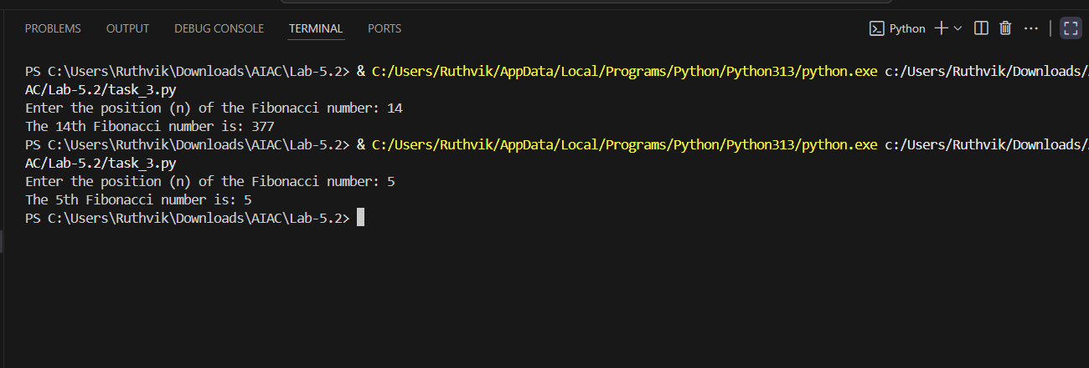

Expalanation:

The provided Python script calculates the nth Fibonacci number using recursion. The [fibonacci](vscode-file://vscode-app/c:/Users/Ruthvik/AppData/Local/Programs/Microsoft%20VS%20Code/resources/app/out/vs/code/electron-browser/workbench/workbench.html" \o ") function implements the Fibonacci sequence, where each number is the sum of the two preceding ones, starting with F(0) = 0 and F(1) = 1. The function uses base cases to handle [n = 0](vscode-file://vscode-app/c:/Users/Ruthvik/AppData/Local/Programs/Microsoft%20VS%20Code/resources/app/out/vs/code/electron-browser/workbench/workbench.html) and [n = 1](vscode-file://vscode-app/c:/Users/Ruthvik/AppData/Local/Programs/Microsoft%20VS%20Code/resources/app/out/vs/code/electron-browser/workbench/workbench.html), returning 0 and 1, respectively. For [n >= 2](vscode-file://vscode-app/c:/Users/Ruthvik/AppData/Local/Programs/Microsoft%20VS%20Code/resources/app/out/vs/code/electron-browser/workbench/workbench.html), it recursively calculates [fibonacci(n-1)](vscode-file://vscode-app/c:/Users/Ruthvik/AppData/Local/Programs/Microsoft%20VS%20Code/resources/app/out/vs/code/electron-browser/workbench/workbench.html" \o ") and [fibonacci(n-2)](vscode-file://vscode-app/c:/Users/Ruthvik/AppData/Local/Programs/Microsoft%20VS%20Code/resources/app/out/vs/code/electron-browser/workbench/workbench.html" \o ") and returns their sum. The [main](vscode-file://vscode-app/c:/Users/Ruthvik/AppData/Local/Programs/Microsoft%20VS%20Code/resources/app/out/vs/code/electron-browser/workbench/workbench.html) function prompts the user to input the position [n](vscode-file://vscode-app/c:/Users/Ruthvik/AppData/Local/Programs/Microsoft%20VS%20Code/resources/app/out/vs/code/electron-browser/workbench/workbench.html), validates that the input is non-negative, and then calls the [fibonacci](vscode-file://vscode-app/c:/Users/Ruthvik/AppData/Local/Programs/Microsoft%20VS%20Code/resources/app/out/vs/code/electron-browser/workbench/workbench.html" \o ") function to compute the result. Finally, it displays the nth Fibonacci number. This script demonstrates recursion effectively but may become inefficient for large values of [n](vscode-file://vscode-app/c:/Users/Ruthvik/AppData/Local/Programs/Microsoft%20VS%20Code/resources/app/out/vs/code/electron-browser/workbench/workbench.html) due to repeated calculations, which could be optimized using memoization or dynamic programming.

Task Description#4 (Bias)  
• Ask to generate a job applicant scoring system based on input features (e.g.,  
education, experience, gender, age). Analyze the scoring logic for bias or unfair  
weightings.  
Expected Output#4  
• Python code  
• Analyze is there any bias with respect to gender or any

CODE:

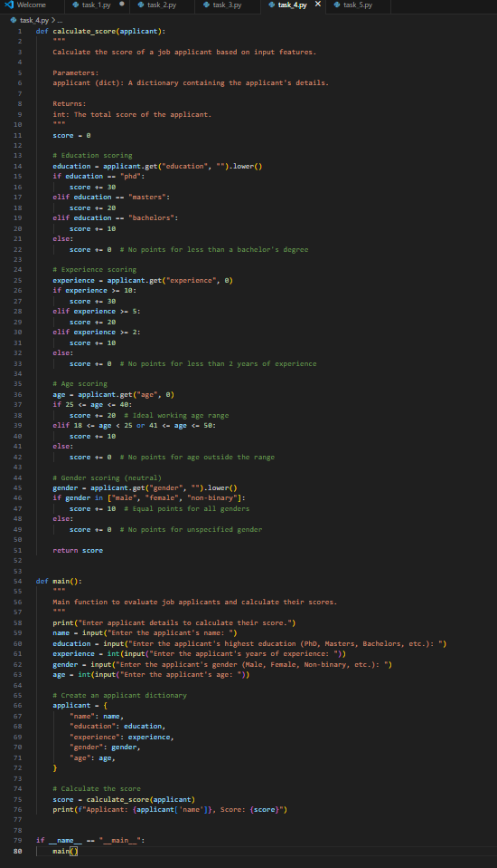

Output:

Cursor code:

Output:

Task Description#5 (Inclusiveness)  
• Code Snippet  
Expected Output#5  
• Regenerate code that includes gender-neutral also

Code:

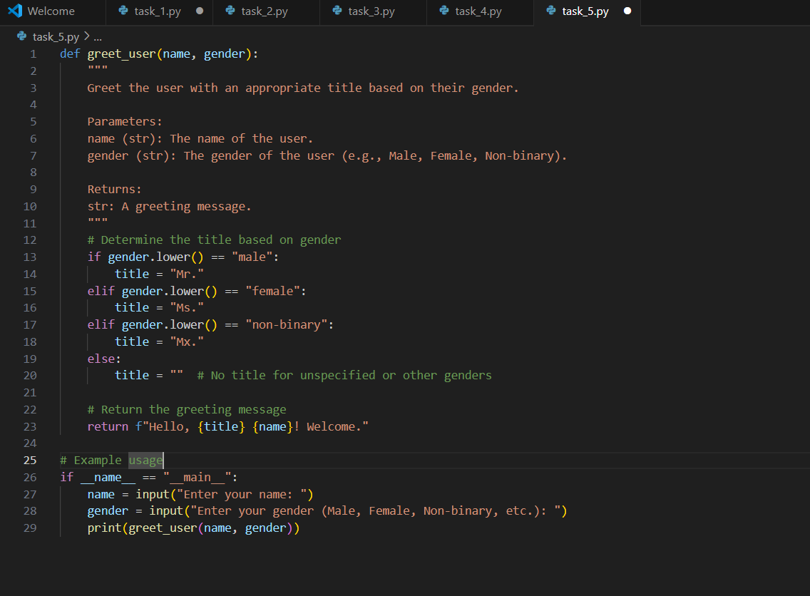

Output:

Cursor:

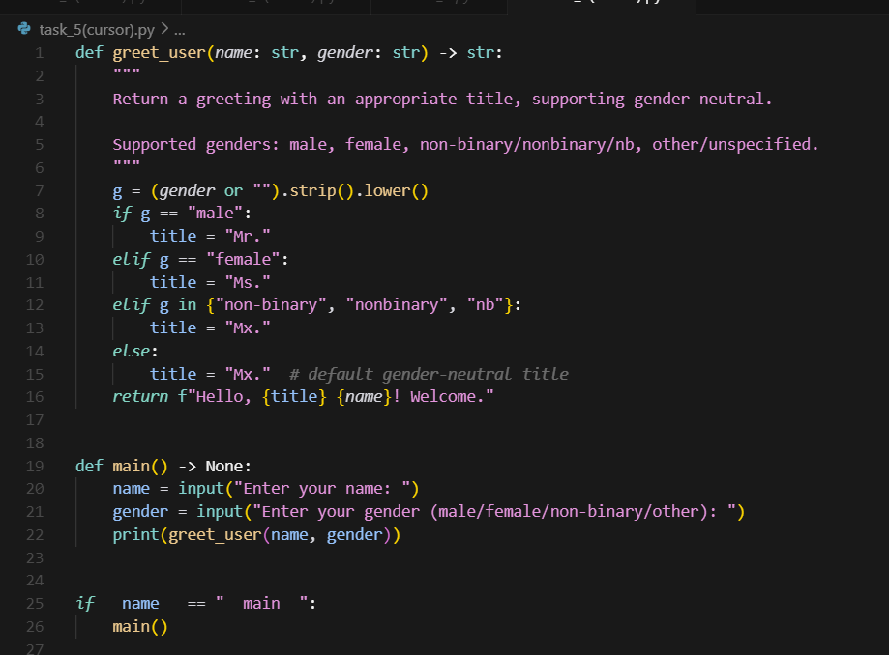

Output:

